|  |
| --- |
| Toy Robot Simulation  Technical Details, Implementation and Test Results |

Standards Documentation

|  |  |
| --- | --- |
| Abstract: | This document presents the Toy Robot Simulation Technical details, Implementation and Test Results |
| Version Number: | 1.0 |
| Date Issued: | 18/10/2016 |

| Contacts for Enquiries | | |
| --- | --- | --- |
| **Document Author (Technical)** | Name: | Suman Ganguly |
|  | Phone: | 0469 905 902 |
| Email: | [suman.ganguly1981@gmail.com](mailto:suman.ganguly1981@gmail.com) |

Version History

| Version | Release Date | Released By | Description of Changes |
| --- | --- | --- | --- |
| 0.1 | 18/10/2016 | Suman Ganguly | Initial version with technical and implementation details and test results |
| Note:  When significant changes are occurring, the Version should become the next whole number. | | | |

**Document Stakeholders**

This document will be distributed to the following people:

| Department | Stakeholder | Sign Off (S) or Review (R) |
| --- | --- | --- |
| IT Talent Acquisition Specialist | Martha Creedon | R |
|  |  |  |
|  |  |  |

Table of Contents

1 Introduction 5

1.1 Purpose of Document 5

1.2 Scope 5

1.2.1 In-Scope 5

1.2.2 Out-of-Scope 5

1.3 Assumptions 6

1.4 Dependencies 6

1.5 Risks 6

1.6 Abbreviation, Definitions & Synonyms 6

1.7 References 6

1.8 Design Considerations and Constraints 6

1.8.1 Considerations 7

1.8.2 Constraints 7

1.9 Conventions and Standards Followed 7

1.10 Technology 7

2 Design Decisions 8

3 Build Process 9

4 Implementation Approach 10

5 Test Results 11

# Introduction

## Purpose of Document

This document will provide the technical and implementation detail for Toy Robot Simulation application.

## Scope

### In-Scope

The following items are included in this document

* Technical details of the application
* Implementation detail
* Test Results

### Out-of-Scope

The following items are out of scope of this document

* Graphical representation of the Toy Robot Simulation

## Assumptions

|  |  |
| --- | --- |
| **Name** | **Rationale** |
| JDK 1.7 has been used to develop the application | Java has been recommended to be used to implement the solution |
|  |  |
|  |  |

## Dependencies

|  |  |
| --- | --- |
| **Name** | **Rationale** |
| None |  |

## Risks

|  |  |  |  |
| --- | --- | --- | --- |
| **Risk Id** | **Consequences/Impact** | **Mitigation Plan** | **Owner** |
| R001 | Non availability of production environment details | The application may need to be upgraded or modified based on production environment technology stack | Suman Ganguly |

## Abbreviation, Definitions & Synonyms

This section contains business and technical terms used within this document.

| **Abbreviation** | **Definition** |
| --- | --- |
| None |  |
|  |  |
|  |  |

## References

The following information sources were referenced during the production of this document:

| # | Document Name | Version | Location |
| --- | --- | --- | --- |
| 1 | PROBLEM.md file has been referred to implement the solution |  | Shared via email |

## Design Considerations and Constraints

### Considerations

* The design must take into account current architecture and the ability to re-utilise it where applicable
* The classes are designed so that each class is performing single activity.
* The classes are not tightly coupled and so are less prone for change.

### Constraints

Non availability of production environment details

## Conventions and Standards Followed

* Java coding standard has been followed for logging, exception handling.
* The class files contain enough comments for class/method definition for java doc generation.

## Technology

|  |  |
| --- | --- |
| Component | Technology |
| Toy Robot Simulation Implementation Language | JDK 1.7 |
| Application Build | Maven 3.1.1 |
| Unit Testing | Junit 4.11 |
| Code Coverage | Jcoco |

# Design Decisions

|  |  |  |  |
| --- | --- | --- | --- |
| **Decision Id** | **Decision** | **Pros / Cons** | **Alternatives Considered** |
| DD-01 | Maven has been used to build the application | Pros   * This helps to build and package the application artefacts   Cons   * None | Ant can also be used to build the application |
| DD-02 | Junit test framework has been used to unit test the application | Pros   * This helps to test the functional paths in the application during the build time of the application code   Cons   * None | TestNG can also be used to create unit test cases |
| DD-03 | Jcoco code coverage framework has been used | Pros   * This helps us to identify the percentage of the code has been unit tested before deploying the application   Cons   * None | Cobertura can also be used to identify the unit test code coverage |
| DD-04 | JDK1.7 has been used to build the application | Pros   * None   Cons   * None | JDK 1.8 can also be used to build the application |

# Build Process

Maven has been used to build the application.

Please run the following command to build the application from the project root directory (where pom.xml file is located)

# mvn clean install

Note: please note, the following environment variables should exists in the environment before building the application

|  |  |
| --- | --- |
| **Variable Name** | **Variable value** |
| JAVA_HOME | Java Home directory in the machine/environment |
| M2 | Maven bin directory path |

This build process will generate the artefact jar file under Project Root\target folder.

Following libraries are used while building the application by maven

1. maven-compiler-plugin – version 3.1
2. maven-jar-plugin – version 2.4
3. jacoco-maven-plugin – version 0.7.5.201505241946
4. junit – 4.11

# Implementation Approach

Download the following directories from the project source location

* target – this contains actual jar artefact - ToyRobotSimulation-1.0-SNAPSHOT.jar
* scripts – this folder contains the script file to be run to execute the application
* testfile – this folder contains a test file – **commands.txt** – this file can be used for testing

In order to run the application, open **command prompt** or **unix/linux shell** and change the directory location to the location where script folder is located.

The script folder contains scripts to be run to execute the application:

* Windows

Command to run the program in windows machine is shown in bold below. It needs two parameters in input. Those are:

C - for commandline input

F - File input and next is the actual file location

**setup C**

**setup F .\..\testfile\commands.txt**

Note: Please update the **JAVA_HOME** variable value in setup.cmd as per your java home directory location.

* Unix/Linux

Command to run the program in unix/linux machine is shown in bold below. It needs two parameters in the input. Those are:

C - for commandline input

F - File input and next is the actual file location

**./setup.sh C**

**./setup.sh F ./../testfile/commands.txt**

Note: Please update the **JAVA_HOME** variable value in setup.sh as per your java home directory location.

Note: existing jar artefact has been build using **JDK 1.7** version, so **JDK 1.7 or higher version** is required to run the application.

# Test Results

Case 1:

|  |  |  |  |  |  |  |
| --- | --- | --- | --- | --- | --- | --- |
| **Sl. No.** | **Environment** | **Mode** | **Input Commands** | **Expected Output** | **Actual Output** | **Result** |
| 1 | Windows | Command Line | PLACE 0,0,NORTH  MOVE  REPORT | 0,1,NORTH | 0,1,NORTH | Screen Shot 1# |
| 2 | Windows | Command Line | PLACE 0,0,NORTH  LEFT  REPORT | 0,0,WEST | 0,0,WEST | Screen Shot 2# |
| 3 | Windows | Command Line | PLACE 1,2,EAST  MOVE  MOVE  LEFT  MOVE  REPORT | 3,3,NORTH | 3,3,NORTH | Screen Shot 3# |
| 4 | Windows | File | PLACE 0,0,NORTH  MOVE  MOVE  MOVE  MOVE  MOVE  **MOVE**  RIGHT  MOVE  MOVE  MOVE  MOVE  MOVE  **MOVE**  REPORT  **Note: Exception/additional moves** | 5,5,EAST | 5,5,EAST | Screen Shot 4# |
| 5 | Cygwin | Command Line | PLACE 0,0,NORTH  MOVE  REPORT | 0,1,NORTH | 0,1,NORTH | Screen Shot 5# |
| 6 | Cygwin | Command Line | PLACE 0,0,NORTH  LEFT  REPORT | 0,0,WEST | 0,0,WEST | Screen Shot 6# |
| 7 | Cygwin | Command Line | PLACE 1,2,EAST  MOVE  MOVE  LEFT  MOVE  REPORT | 3,3,NORTH | 3,3,NORTH | Screen Shot 7# |
| 8 | Cygwin | File | PLACE 0,0,NORTH  MOVE  MOVE  MOVE  MOVE  MOVE  **MOVE**  RIGHT  MOVE  MOVE  MOVE  MOVE  MOVE  **MOVE**  REPORT  **Note: Exception/additional moves** | 5,5,EAST | 5,5,EAST | Screen Shot 8# |

Screen Shot #1

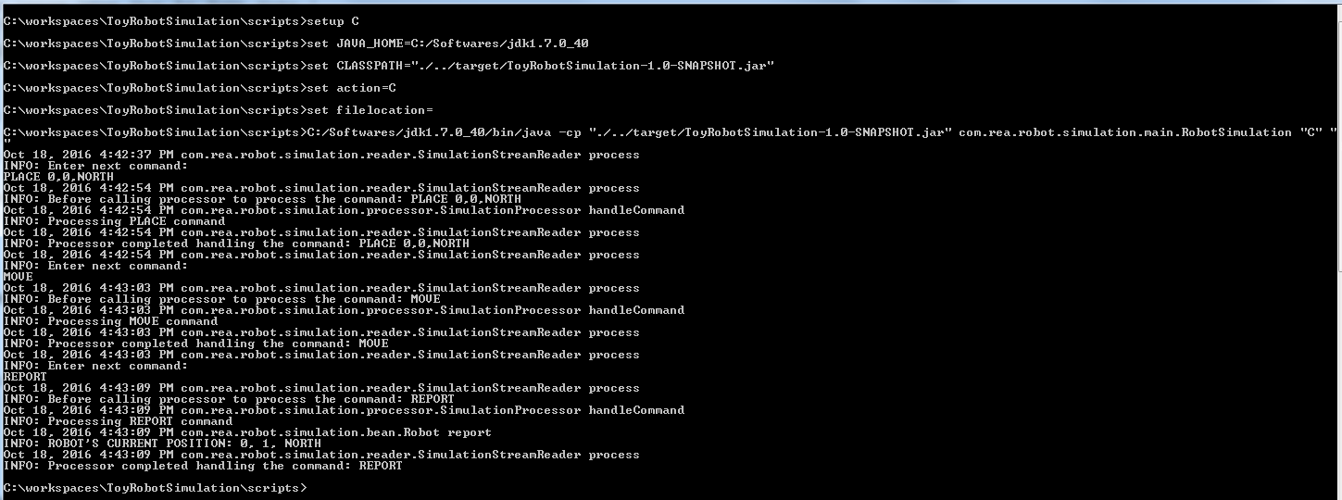

Screen Shot #2

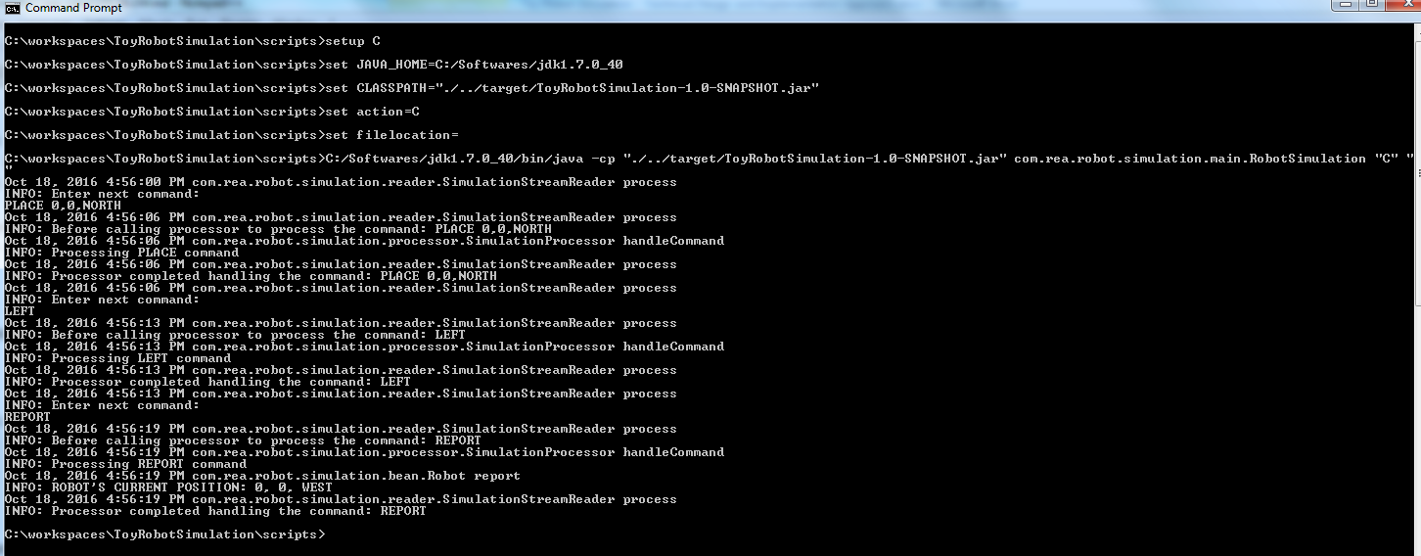

Screen Shot 3#

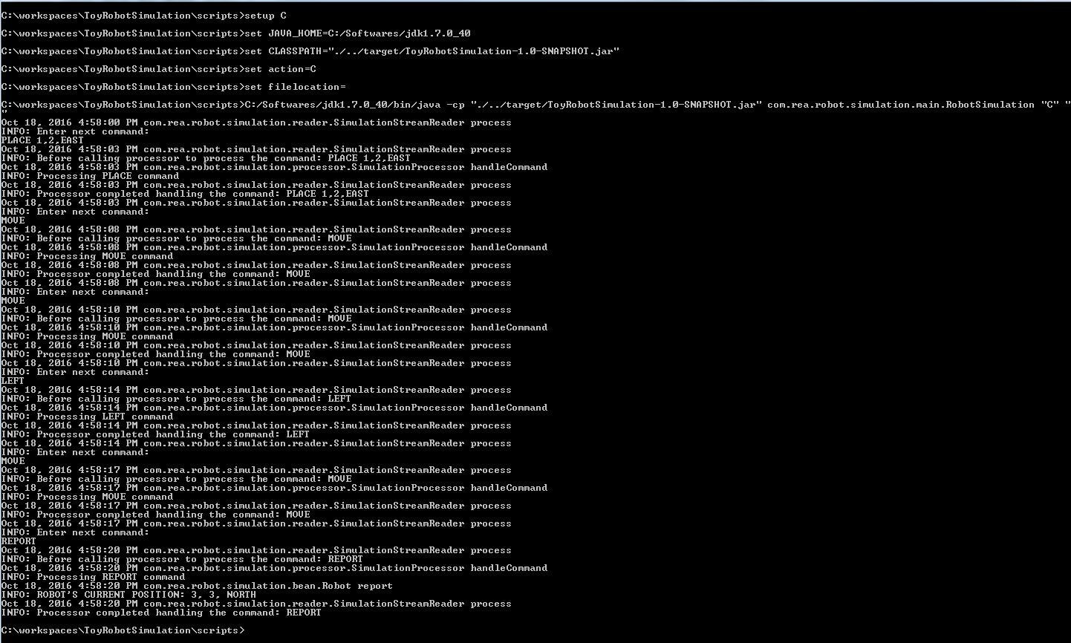

Screen Shot 4#

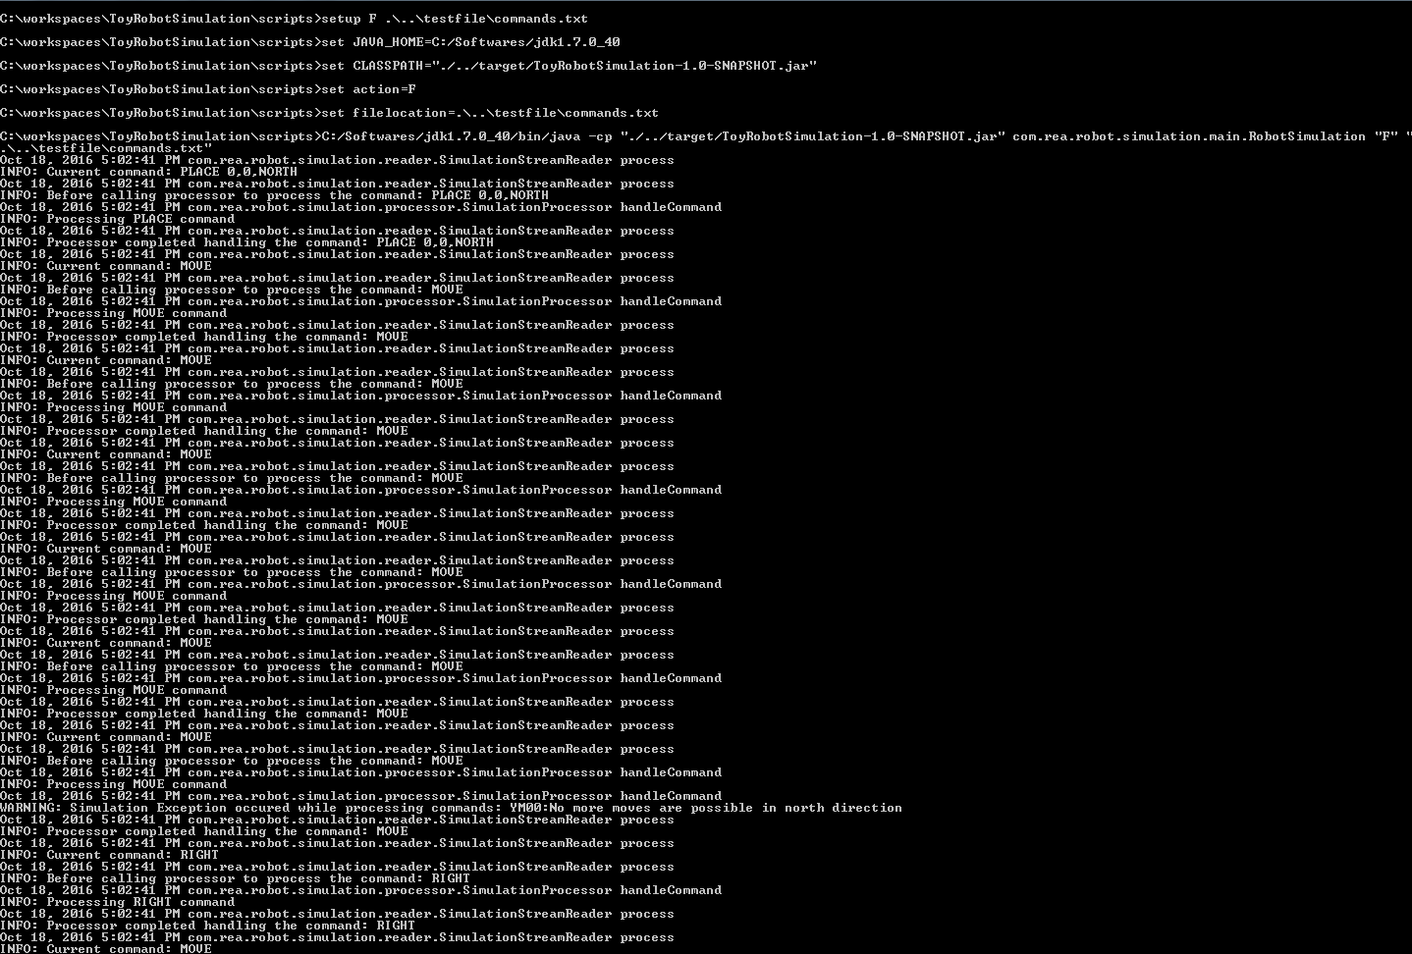

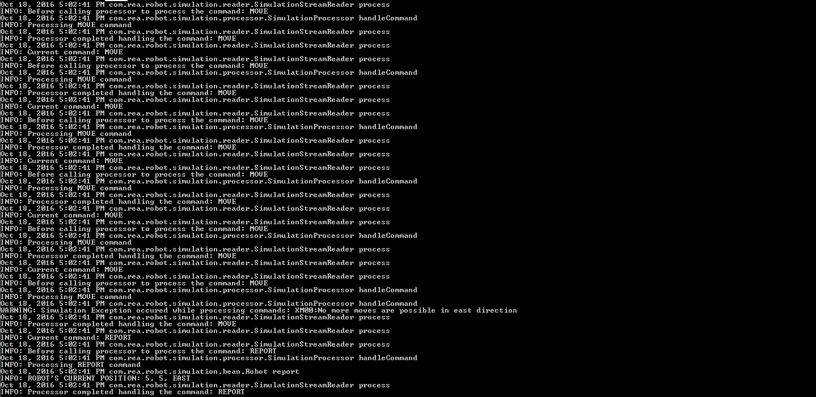

Screen Shot 5#

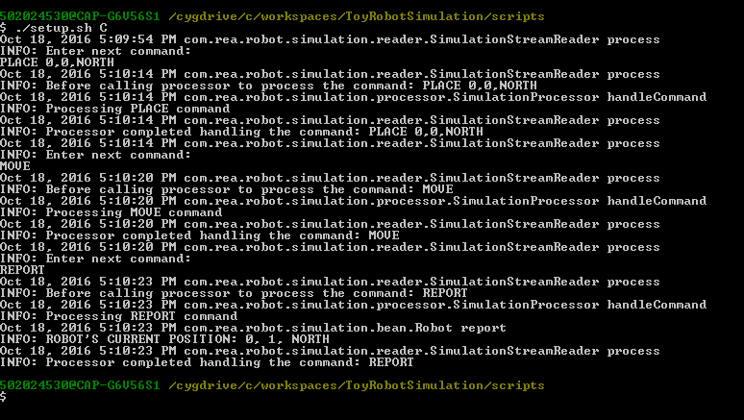

Screen Shot 6#

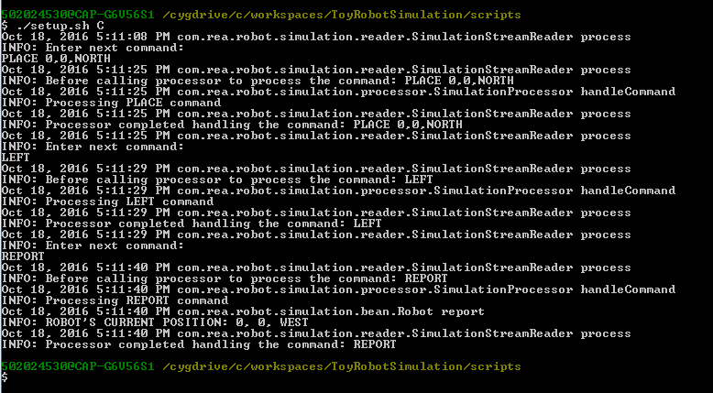

Screen Shot 7#

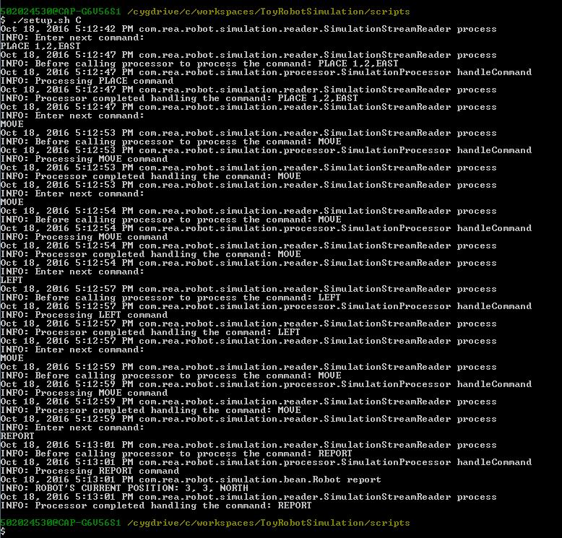

Screen Shot 8#

